*In this project, I extracted data from SQL, analyzed it in Excel and visualized it in Tableau*

For extraction of data in SQL and combining various tables for analysis, the code below was used:

**SQL Script for Data Tables**

SELECT   
 ord.order_id,  
 CONCAT(cus.First_name, ' ',cus.last_name) AS 'Customers',  
 cus.city,  
 cus.state,  
 ord.order_date,  
 SUM(ite.Quantity) AS 'Total_Units',  
 SUM(ite.Quantity*ite.list_price) AS 'revenue',  
 pro.product_name,  
 cat.Category_name,  
 sto.store_name,  
 CONCAT(sta.First_name,' ',sta.last_name) AS 'Sales_rep'  
FROM Sales.orders ord  
Join sales.customers cus  
ON ord.customer_id=cus.customer_id  
Join sales.order_items ite  
ON ord.order_id=ite.order_id  
Join production.products pro  
ON ite.product_id=pro.product_id  
JOIN Production.categories cat  
ON pro.category_id=cat.category_id  
Join sales.stores sto  
ON ord.store_id=sto.store_id  
JOIN sales.staffs sta  
ON Ord.staff_id=sta.staff_id  
GROUP BY   
 ord.order_id,  
 CONCAT(cus.First_name, ' ',cus.last_name),  
 cus.city,  
 cus.state,  
 ord.order_date,  
 pro.product_name,  
 cat.Category_name,  
 sto.store_name,  
 CONCAT(sta.First_name,' ',sta.last_name)

After joining multiple tables with critical insights for the analysis, a brief like the image below is obtained.

**SQL Data Extract**

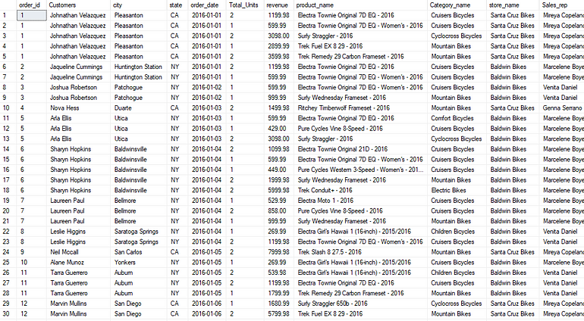

The SQL dataset was consequently connected to an Excel workbook, where pivot tables were created as a basis for a comprehensive dashboard. A dashboard showing total annual revenue, monthly revenue, revenue per product category, each store’s revenue, revenue per sales person and top ten customers was designed.

**Excel Dashboard**

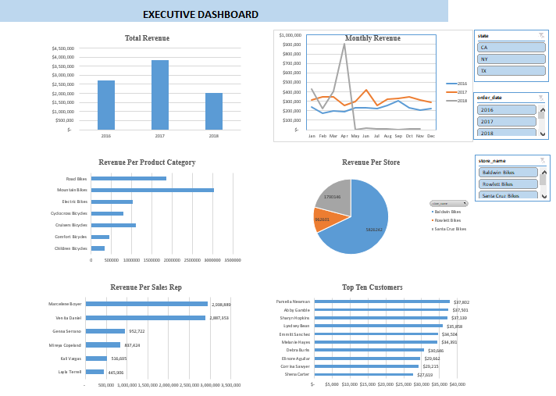

**Tableau Dashboard**

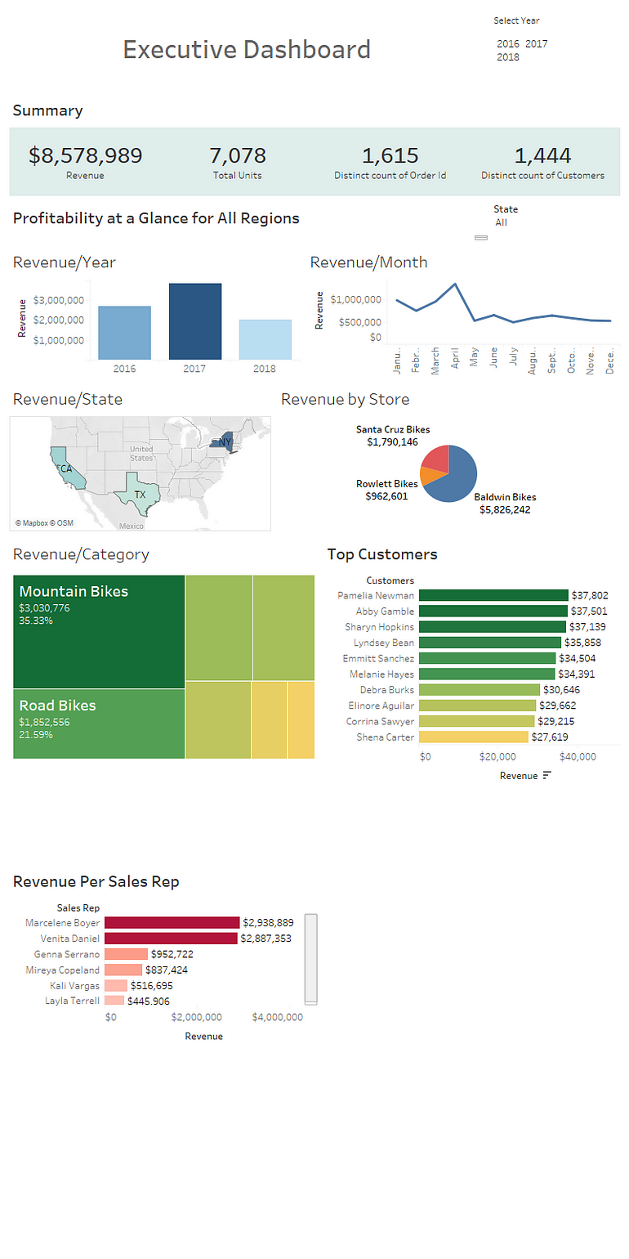

**Insights**

· Total revenue for the three years was $8,578,989, from the sale of 7,078 bicycles to 1,444 customers.

· 2017 had the highest revenue at $3,845,515 from selling 3,099 units to 684 customers.

· April had the highest sales at $1,350,509 revenue, while July had the lowest revenue at $491,532.

· Baldwin Bikes constituted 68% of total revenue, with Santa Cruz Bikes at 21% and the least proportion of revenue was from Rowlett bikes with 11%.

· The product category with the highest revenue was mountain bikes at 35.33%, followed by road bikes at 21.59% and cruisers bikes with 12.93%.